**Health & Safety Talk**

Toolbox Talk

**Incident Reporting / First Aid**

Incident reporting is an important process that needs to be followed in order for the businesses to put in place control measures to prevent further and repeated incidents.

Some injuries have a long latency period, and without documentation it would be hard to establish a cause and effect relationship.

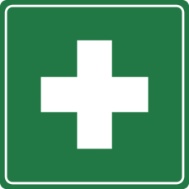

**What are the risks?**

* No way to monitor incident/injury trends
* No corrective actions taken to prevent further incidents
* What could have been a preventable hazard results in a workplace injury or death.
* Potential prosecution for the individual involved and business

**What should be done?**

* Always report a hazard, incident or injury to management so that it can be investigated and have controls implemented to prevent any recurrence.
* Document all hazards and incidents in a register of injuries.
* Ensure you are aware of who the onsite first aider is and location of the first aid kit.
* If you are the trained first aider, notify your manager if your first aid certificate is about to expire (certificates expire every 3 years) so a refresher course can be organised.

**Who is responsible?**

Everyone is responsible for reporting hazards, near misses and injuries to their manager. A person delegated by management will then be responsible for implementing the relevant control measures. Management and delegated First Aiders are responsible for maintaining the first aid kit.

|  |  |
| --- | --- |
| **Consultation** |  |

**Date of Meeting:**_____________________

**Attendees** (list attendees present)

|  |
| --- |
|  |

**Items Discussed**

|  |
| --- |
|  |

**Action Items**

|  |
| --- |
|  |

**Management Sign Off**

**Name:** _______________________________________

**Sign:** ___________________________________ **Date:** ______________________________